Ideation Phase
Brainstorm & Idea Prioritization Template

Date | 31 January 2025
Team ID | LTVIP2026TMIDS66363
Project Name | Asset Management Portal
Maximum Marks | 4 Marks

Brainstorm & Idea Prioritization Template:
Brainstorming provides an open environment that encourages team members to share creative ideas while developing an Asset Management Portal. It helps generate solutions for asset tracking, maintenance, allocation, reporting, and security. By prioritizing idea quantity over immediate evaluation, innovative concepts such as automated tracking, dashboards, and smart alerts can be explored and improved collaboratively.
Use this template in brainstorming sessions so your team can exchange ideas, prioritize useful features, and shape effective asset management solutions even when working remotely.
Reference: https://www.mural.co/templates/brainstorm-and-idea-prioritization
Step-1: Team Gathering, Collaboration and Select the Problem Statement

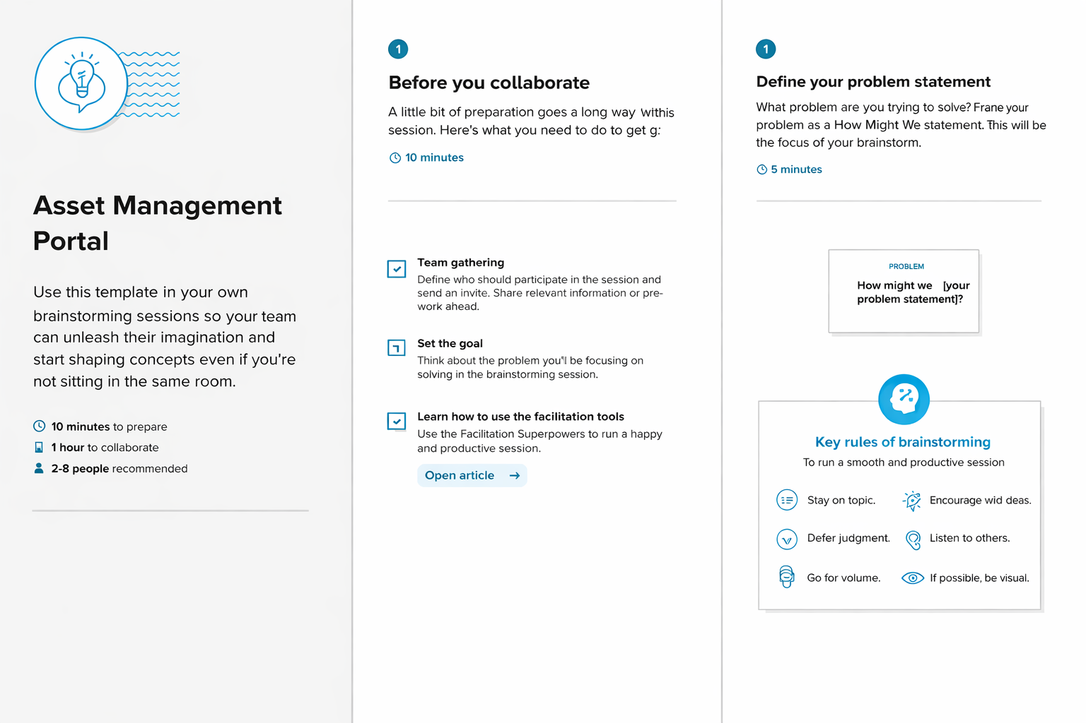

Step-2: Brainstorm, Idea Listing and Grouping
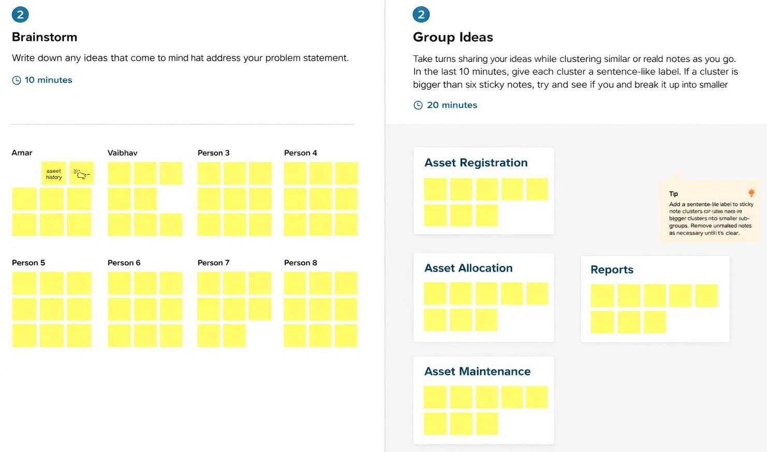

Step-3: Idea Prioritization
